

**Excel Assignment - 11**

1. Use the below table for the following Questions.

| **Roll**  **No.** | **Name of the student** | **Sub-1** | **Sub-2** | **Sub-3** | **Sub-4** | **Sub-5** | **Sub-6** |
| --- | --- | --- | --- | --- | --- | --- | --- |
| 100101 | Rohan | 72 | 55 | 52 | 69 | 95 | 32 |
| 100102 | Mo han | 65 | 51 | 63 | 85 | 71 | 69 |
| 100103 | Ravi meheta | 72 | 56 | 78 | 85 | 47 | 68 |
| 100104 | Ruby tondon | 68 | 71 | 85 | 84 | 78 | 60 |
| 100105 | Radhika gupta | 80 | 78 | 58 | 65 | 68 | 45 |
| 100106 | Rakhi | 61 | 78 | 45 | 62 | 75 | 64 |
| 100107 | david | 78 | 69 | 96 | 52 | 63 | 87 |
| 100108 | mon ika mis hra | 96 | 85 | 86 | 84 | 45 | 63 |
| 100109 | Tommy singh | 75 | 63 | 54 | 63 | 61 | 98 |
| 100110 | p.rakesh | 63 | 52 | 96 | 87 | 78 | 45 |

1. Find the Minimum Marks and Maximum marks scored by each student.

Answer: 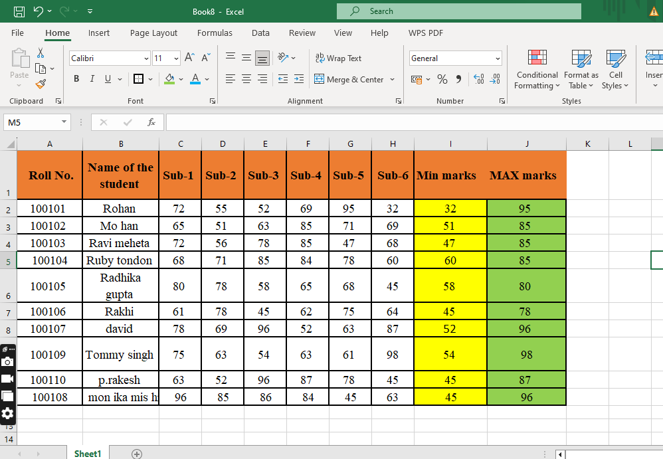

2. Calculate the totals for each student, use conditional formatting to highlight the top students who have scored more than 480.

Answer: 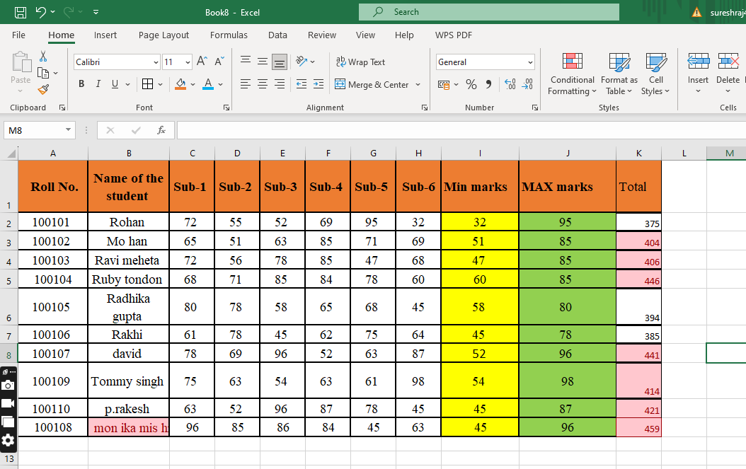

3. Calculate the length of the names of each student.

Answer:



4. Replace the Name Rakhi with Rocky. Use Formulas

Answer: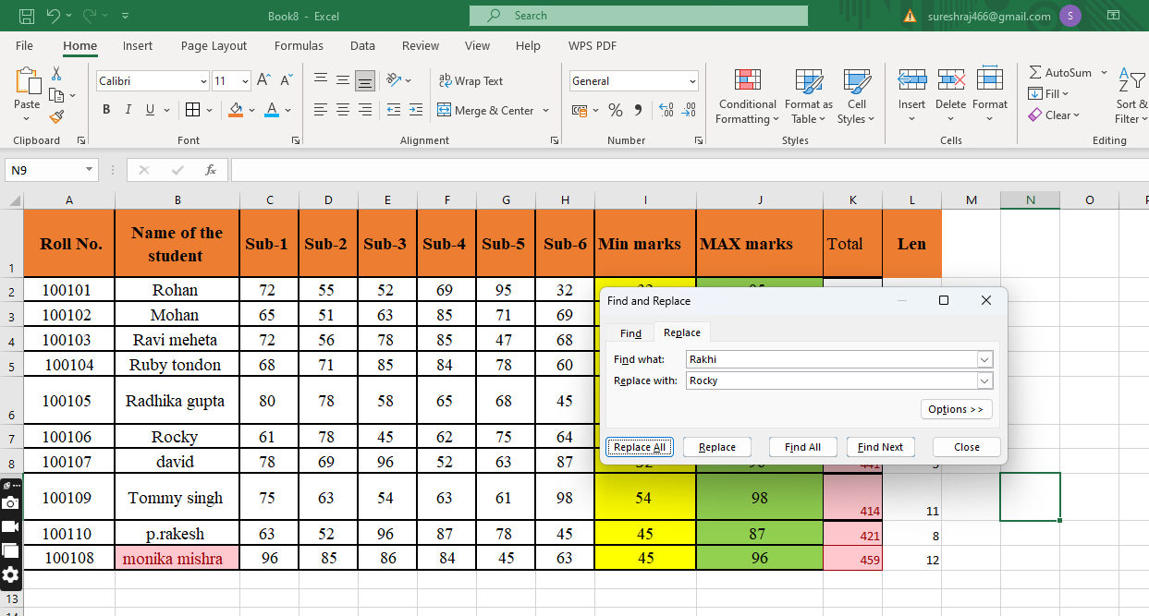

5. Combine the Roll Numbers and Names. Use formulas. The end result should look like below.

100101Rohan

Answer: 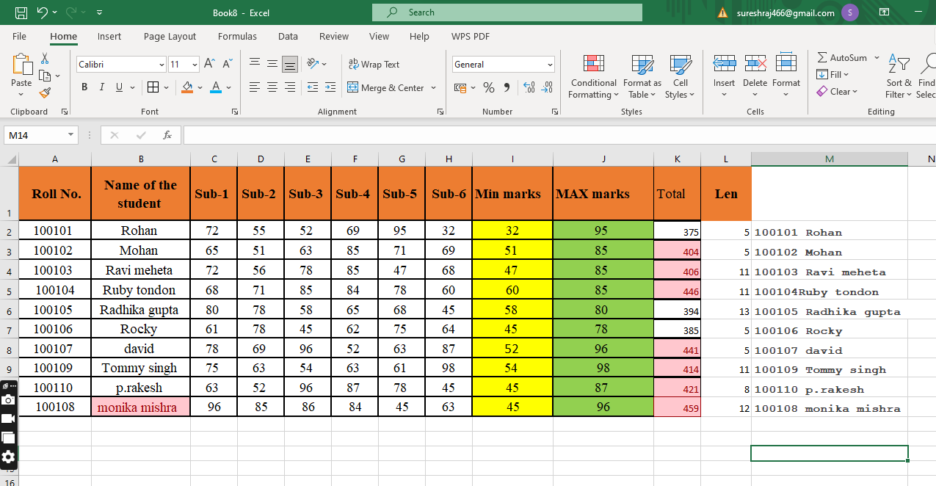

6. As you can see that some names have spacing issues. Use Formulas to correct that spacing. Also ensure that the names and surnames start with a capital letter

Answer: 